CS 255 System Design Document Template

This template lays out all the different sections that you need to complete for Project Two. Each section has guidance to prompt your thinking. You will need to continually reference the interview transcript as you work to make sure that you are addressing your client’s needs. There is no required length for the final document. Instead the goal is to complete each section based on what your client’s needs are. Remove this note when you are finished, and replace all bracketed text with the relevant information.

UML Diagrams

UML Use Case Diagram

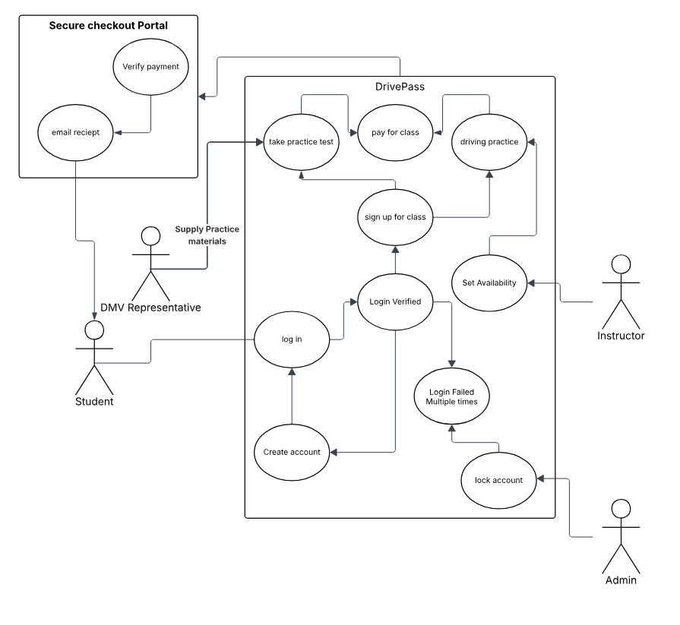

UML Activity Diagrams

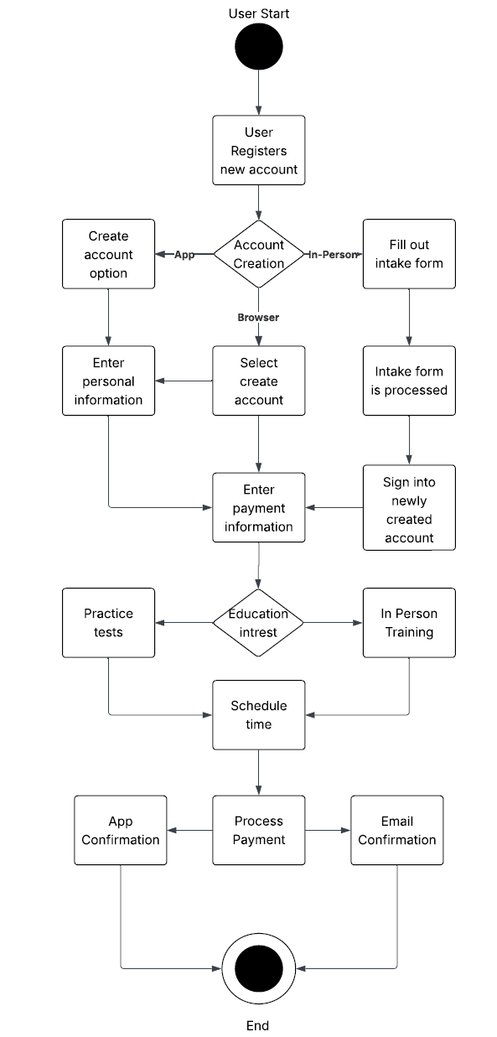

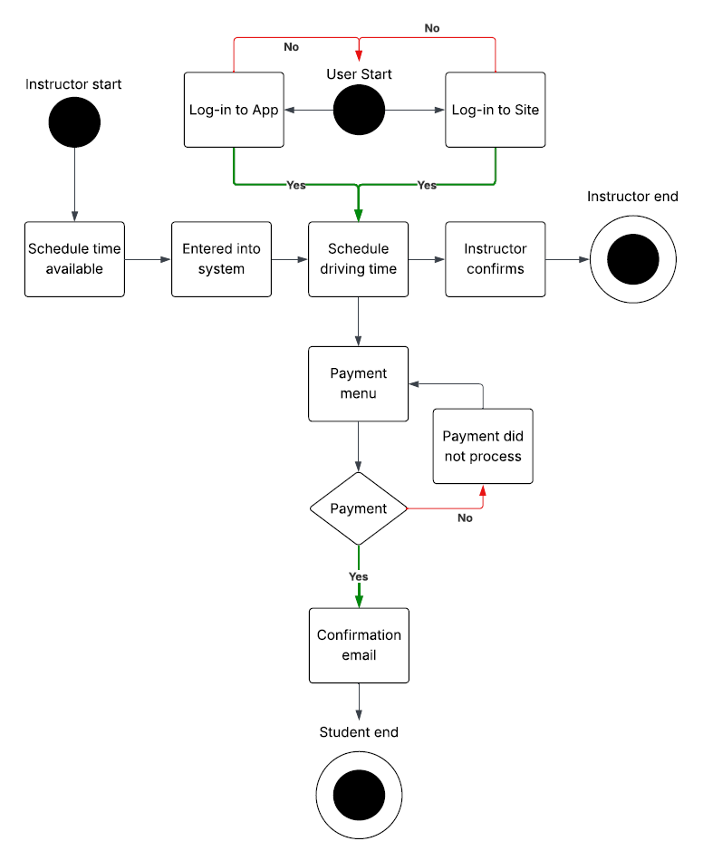

UML Sequence Diagram
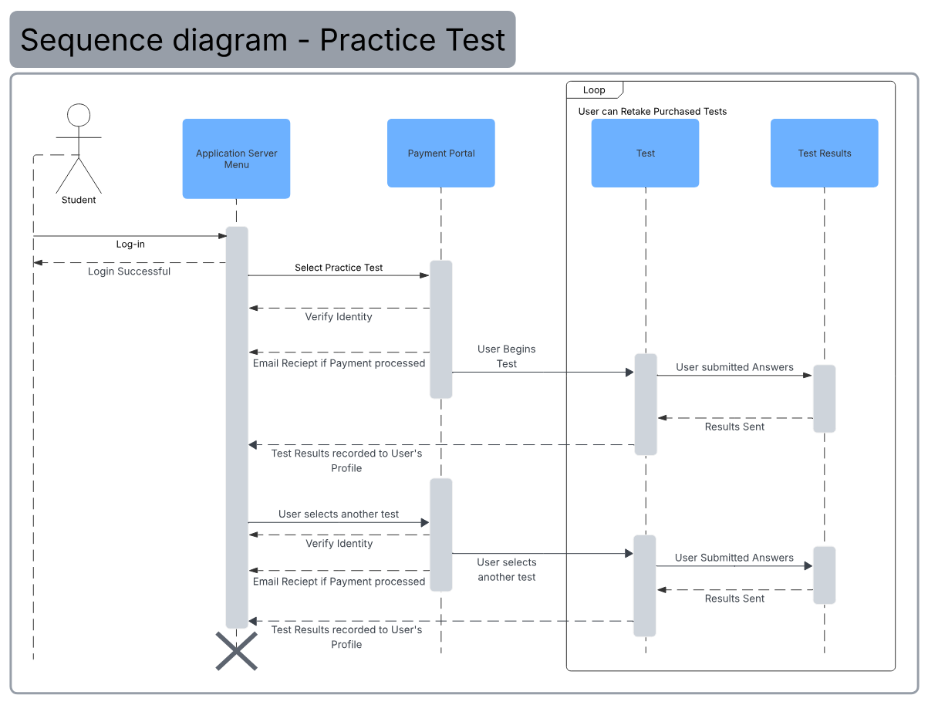

UML Class Diagram

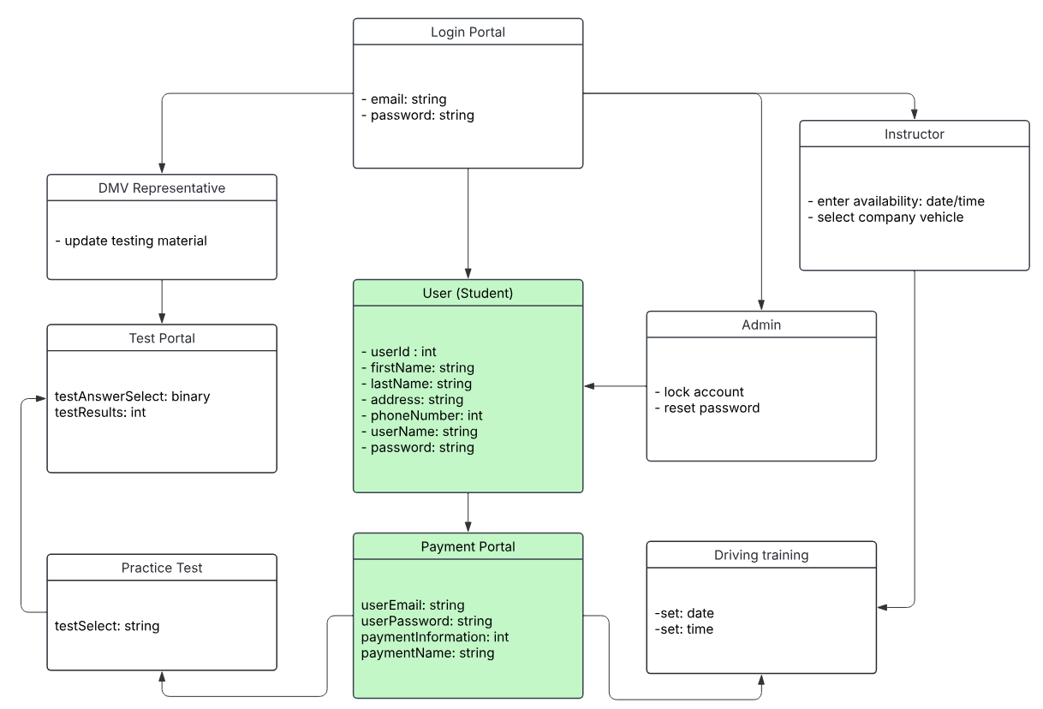

Technical Requirements

I envision that DrivePass would start small to keep costs low and maintenance as low as possible. To achieve this I think that a cloud-based server would be very effect. With low traffic and low data transference this would mean our cost for cloud hosting would be very cheap. This could potentially be an issue if DrivePass’s userbase scales up very quickly- but we should wait and see. Ideally on our side we would should supply our admin workers with some midrange laptops to help with IT and monitor for attacks. I think we should also employ the use of an outside pay service to keep our customers data safe. Doing this also means we would not be holding onto their payment data but another organization, shielding us from potential data breach liabilities. Finally a small office could be run for in-person customers- although personally I don’t think this is necessary. The majority of our clients will be young people who are more connected and comfortable with the internet and applications.

